Project Design Phase-II
Data Flow Diagram & User Stories
Date | 4 September 2026
Team ID | Servicenow
Project Name | Automated Network Request Management
Maximum Marks | 4 Marks

Data Flow Diagrams
A Data Flow Diagram (DFD) is a visual representation of how data moves through the Automated Network Request Management system — how a request enters the system, how it is validated, approved, provisioned, and logged, and where data is stored along the way.
Level 0 – Context Diagram
Shows the system as a single process and its interactions with the three external entities: the Employee/Requester, the Approver/Manager, and the Network Admin (IT Team).
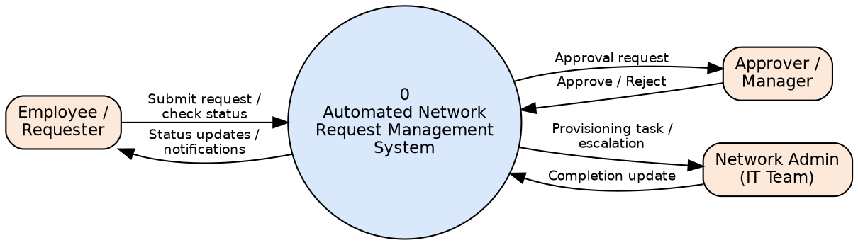
Figure 1: Level 0 Context DFD – Automated Network Request Management System
Level 1 – Detailed DFD
Decomposes the system into its core processes — authentication, request validation, approval routing, automated provisioning, notification, and logging/reporting — along with the data stores each process reads from or writes to.
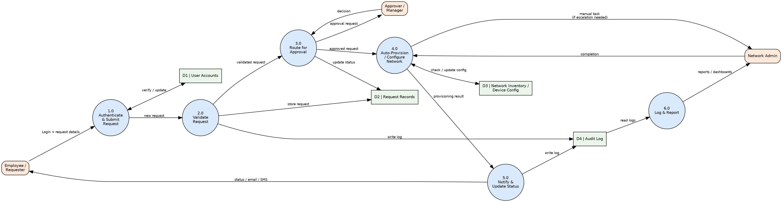
Figure 2: Level 1 DFD – Automated Network Request Management System

User Stories
The table below lists the user stories for the Automated Network Request Management product, grouped by user type and functional requirement (epic).
User Type | Functional Requirement (Epic) | User Story Number | User Story / Task | Acceptance Criteria | Priority | Release
Employee (Requester) | Registration & Login | USN-1 | As an employee, I can register on the portal using my company email and employee ID so that I can raise network requests. | Employee can log in successfully with the registered credentials and lands on the dashboard. | High | Sprint-1
Employee (Requester) | Registration & Login | USN-2 | As an employee, I can log in using corporate Single Sign-On (SSO) instead of a separate password. | User is redirected to the dashboard immediately after successful SSO authentication. | High | Sprint-1
Employee (Requester) | Request Submission | USN-3 | As an employee, I can submit a network request (VPN access, Wi-Fi access, firewall rule, port opening) by selecting a request type and filling in the required details. | Request is saved with a unique ticket ID and initial status "Pending Approval". | High | Sprint-1
Employee (Requester) | Request Submission | USN-4 | As an employee, I can attach supporting documents (e.g., manager authorization) to my request. | Uploaded file is stored securely and linked to the correct ticket ID. | Medium | Sprint-2
Employee (Requester) | Request Submission | USN-5 | As an employee, I can save an incomplete request as a draft and submit it later. | Draft is retained in "My Requests" until the employee submits or deletes it. | Low | Sprint-3
Employee (Requester) | Dashboard & Tracking | USN-6 | As an employee, I can track the real-time status of all my submitted requests on a single dashboard. | Dashboard shows current stage (Pending / Approved / Provisioning / Completed / Rejected) for every request. | High | Sprint-1
Approver (Manager) | Approval Workflow | USN-7 | As an approver, I receive an automated notification as soon as a request needs my approval. | Email and in-app notification are sent within 1 minute of request submission. | High | Sprint-1
Approver (Manager) | Approval Workflow | USN-8 | As an approver, I can view full request details and approve or reject the request with comments. | Approval/rejection decision and comments are recorded against the ticket and visible to the requester. | High | Sprint-1
Approver (Manager) | Approval Workflow | USN-9 | As an approver, I can delegate my approval authority to another approver when I am out of office. | Delegated approver can view and act on pending requests during the configured delegation period. | Medium | Sprint-3
Approver (Manager) | Approval Workflow | USN-10 | As the system, requests that are not actioned within the defined SLA are automatically escalated to the next approval level. | Unactioned request is escalated and both approvers are notified once the SLA timer expires. | Medium | Sprint-2
System (Automation Engine) | Automated Provisioning | USN-11 | As the system, I can automatically provision the requested network access once it is approved, without manual admin intervention, for standard request types. | Access is provisioned within the defined SLA and ticket status auto-updates to "Completed". | High | Sprint-2
System (Automation Engine) | Automated Provisioning | USN-12 | As the system, I can validate the requested configuration against network inventory and security policy rules before provisioning. | Requests that violate policy are automatically blocked and routed to a network admin for review. | High | Sprint-2
System (Automation Engine) | Automated Provisioning | USN-13 | As the system, I can automatically revoke or expire access on the date specified in the request. | Access is removed on the expiry date and the requester and admin are notified. | Medium | Sprint-3
Network Admin (IT Team) | Exception Handling | USN-14 | As a network admin, I can view and manually complete any request that fails automated provisioning. | Failed requests appear in an exception queue with the failure reason and can be actioned manually. | High | Sprint-2
Network Admin (IT Team) | Exception Handling | USN-15 | As a network admin, I can view live network inventory and device configuration status from a dashboard. | Dashboard reflects current device/port utilization sourced from the network inventory data store. | Medium | Sprint-2
Employee / Network Admin | Notifications | USN-16 | As an employee, I receive an email/SMS notification whenever the status of my request changes. | Notification is sent within 1 minute of any status change and includes the ticket ID. | High | Sprint-1
Administrator | Reporting & Audit | USN-17 | As an administrator, I can generate reports on request volume, SLA compliance, and average approval turnaround time. | Report can be filtered by date range and department, and exported to CSV/PDF. | Medium | Sprint-3
Administrator | Reporting & Audit | USN-18 | As an administrator, I can view a complete audit log of every action taken on a request for compliance purposes. | Every create/approve/reject/provision/revoke action is logged with timestamp and actor. | High | Sprint-2

